Double Pendulum

Chaotic characteristics of a double pendulum and the impact on numerical solutions.

The equations of a double pendulum were calculated using two program with two different differentiation function to feed to the scipy ode integrator with of type ‘vode’, otherwise the two programs were the same.

Program 1, annotated with s1 had the following derivative

def get_derivatives_double_pendulum(t, state):
''' definition of ordinary differential equation for a
double pendulum
'''
theta1, theta1_dot, theta2, theta2_dot = state

_num1 = -g * (2 * mass_bob1 + mass_bob2) * np.sin(theta1)
_num2 = -mass_bob2 * g * np.sin(theta1-2*theta2)
_num3 = -2*np.sin(theta1-theta2) * mass_bob2
_num4 = theta2_dot * theta2_dot * length_r2 + \
theta1_dot * theta1_dot * length_r1 * np.cos(theta1-theta2)
_den = length_r1 * (2 * mass_bob1 + mass_bob2 - \
mass_bob2 * np.cos(2*theta1-2*theta2))
theta1_doubledot = (_num1 + _num2 + _num3 * _num4) / _den

_num1 = 2 * np.sin(theta1-theta2)
_num2 = (theta1_dot * theta1_dot * length_r1 * (mass_bob1 + mass_bob2))
_num3 = g * (mass_bob1 + mass_bob2) * np.cos(theta1)
_num4 = (theta2_dot * theta2_dot * length_r2 * \
mass_bob2 * np.cos(theta1-theta2))
_den = length_r2 * (2 * mass_bob1 + mass_bob2 - \
mass_bob2 * np.cos(2*theta1-2*theta2))
theta2_doubledot = (_num1 * (_num2 + _num3 + _num4)) / _den

state_differentiated = np.zeros(4)
state_differentiated[0] = theta1_dot
state_differentiated[1] = theta1_doubledot
state_differentiated[2] = theta2_dot
state_differentiated[3] = theta2_doubledot

return state_differentiated

Program 2, annotated with s2 had the following derivative

def get_derivatives_double_pendulum(t, state):
''' definition of ordinary differential equation for a
double pendulum
'''
t1, w1, t2, w2 = state
dt = t1 - t2
_sin_dt = sin(dt)
_den1 = (m1+m2*_sin_dt*_sin_dt)

_num1 = m2*l1*w1*w1*sin(2*dt)
_num2 = 2*m2*l2*w2*w2*_sin_dt
_num3 = 2*g*m2*cos(t2)*_sin_dt+2*g*m1*sin(t1)
_num4 = 0
w1_dot = (_num1+_num2+_num3+_num4)/ (-2*l1*_den1)

_num1 = m2*l2*w2*w2*sin(2*dt)
_num2 = 2*(m1+m2)*l1*w1*w1*_sin_dt
_num3 = 2*g*(m1+m2)*cos(t1)*_sin_dt
_num4 = 0
w2_dot = (_num1+_num2+_num3+_num4)/ (2*l2*_den1)

state_differentiated = np.zeros(4)
state_differentiated[0] = w1
state_differentiated[1] = w1_dot
state_differentiated[2] = w2
state_differentiated[3] = w2_dot

return state_differentiated

The physical properties and initial state at t=0 were:

# physical properties
g = 9.8
length_r1 = 2.0 # meter
length_r2 = 4.0 # meter
mass_bob1 = 10.0 # kg
mass_bob2 = 5.0 # kg

# initial state
theta1_initial = + 120 / 180 * np.pi
theta2_initial = + 180 / 180 * np.pi
theta1_dot_initial = 0 # no initial angular velocity
theta2_dot_initial = 0 # no initial angular velocity

Purely using different equations for the same solution already change the outcome of the numerical results. Up to 15 seconds the two programs show the same result but thereafter they start to deviate as the the plots show for 20 seconds and 25 seconds.

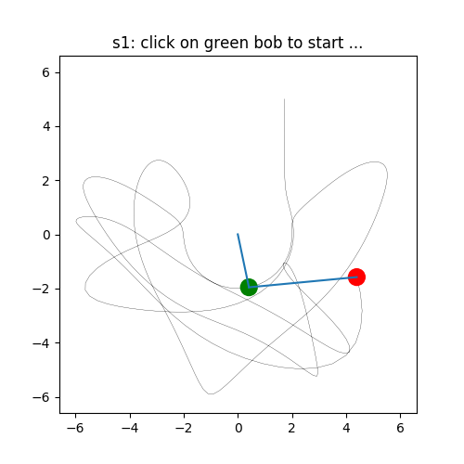  15 seconds | 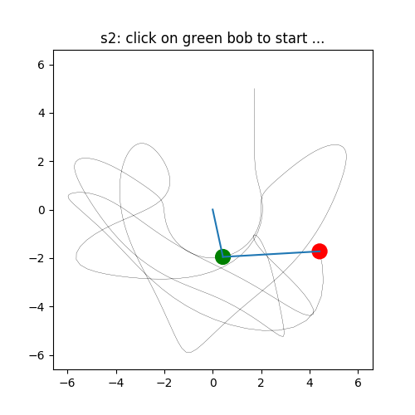
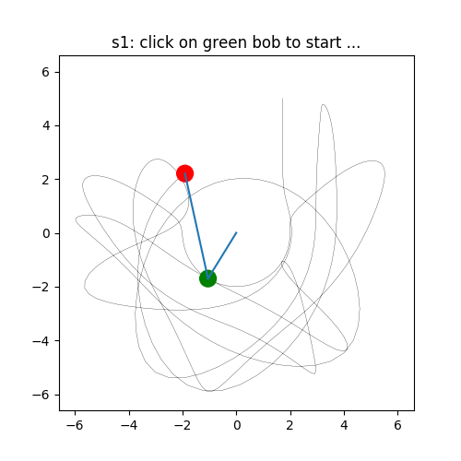  20 seconds | 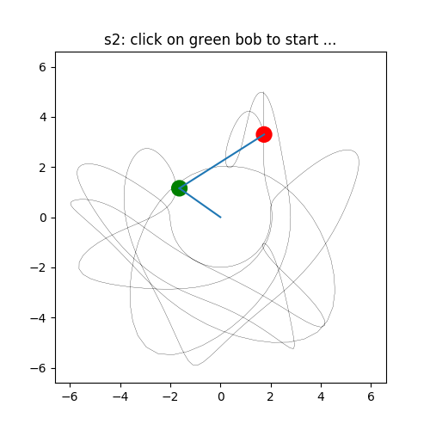
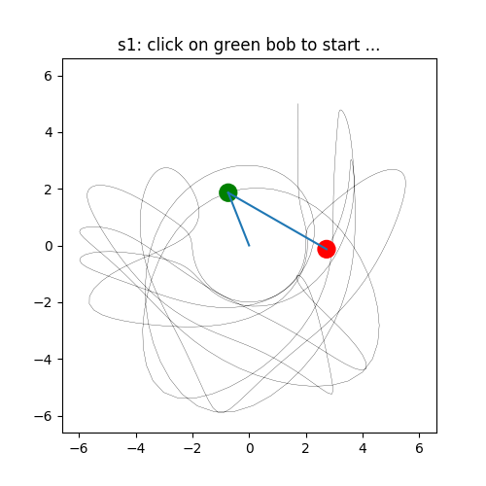  25 seconds | 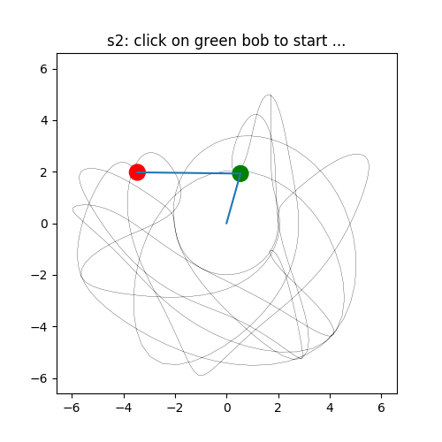

So although each program may give a fairly accurate representation of what the the pendulum is doing at any instance, the actual positions and angular velocities cannot be compared with each other when time increases.

